Abstract template of the 5th International Workshop on Gallium Oxide and Related Materials (IWGO 2024)
A. Author,^{1,}* B. Author,¹ and C. Author²
¹Affiliation, City, State/Prefecture, Country
² Affiliation, City, State/Prefecture, Country
*E-mail: kkkk@ll.mm.nn.jp

The abstract should be original work and summarized in two pages (one page of text and one page of figures and/or tables). The deadline of abstract submission is December 01, 2023. Authors are encouraged to use this template for preparing the abstract. The format guidelines are as follows:
- Paper size: A4
- Margins: 2.5 cm on all sides
- Font type: “Times New Roman” and “Symbol”.
- Font size and style:
- Title – 14 points, Centered, Bold
- Author(s), Affiliation and Address, E-mail address of the corresponding author – 12 points, Centered, Plain
- Presenting authors name must be underlined
- Body text – 11 points, Single-spaced, Plain
- References in the text – should be written in square brackets: [1], [2, 3], [4-6] etc.
- Acknowledgments and References – 10 points, Single-spaced, Plain
- Figure and Table captions – 10 points, Plain

Only a PDF version of the abstract must be submitted online. For more information, please check the workshop website (https://grafox2022.pdi-berlin.de/iwgo-2024/).
Note that the accepted PDF abstracts will be published in an abstract book and distributed to participants at the workshop via USB flash drives.

[1] A. Author B. Author, and C. Author: Journal name Vol., Start page (Year).
[2] A. Author, Title of book (Publisher), Chapter, (Year).
The second page is reserved for figures and/or tables.

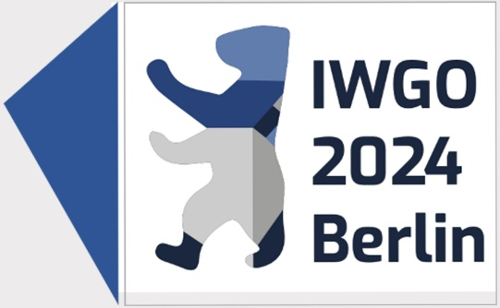

Fig. 1 Logo of IWGO 2024.

Table I List of important dates.

Date | Event
October 15, 2023 | Beginning of abstract submission
December 01, 2023 | Deadline of abstract submission
May 26–31, 2024 | IWGO 2024

