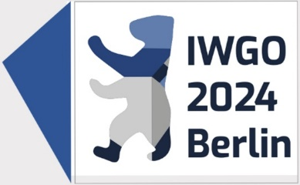

IWGO 2024 Sponsorship Opportunities

Choose the Level of Sponsorship: Offers for Exhibitors
 Platinum: 3,500EUR  1 Day Pass 1500EUR
 Gold: 2,500EUR  3 Day Pass 2500EUR
 Silver: 1,500EUR  Duration of Conference 3000EUR

Additional Opportunities (Optional)

 Sponsoring a Dinner Table 500EUR  3 min Pitch to Conference 1000EUR
 Sponsoring a Coffee Break  Visibility at Welcome
 Sponsoring a Coffee Break Reception 600EUR
(total of 9) 300EUR
 Sponsoring the Welcome
Reception 1500EUR

________________________________________
Company Name*
________________________________________
Contact First (given) Name, Family Name*
________________________________________
Address*
________________________________________
City/State/postal Code/Country*
________________________________________
Email*
________________________________________
Phone/Ext.
Total investment: EUR______________________
Send form to: iwgo2024.sponsors@pdi-berlin.de

Order/Payment: Once your order is processed, you will receive an invoice for payment. Payment is due on the date noted on invoice.
*information required
 Giving a 5min Pitch about the
Company 500EUR
 Sponsoring the Award
Session 1500EUR

 Logo Printed on the Best Paper
Award 400EUR
 Logo Printed on the Student
Award 400EUR
Badge and Lanyard (provided by sponsor)  Shared  200EUR
❒ Exclusive 400EUR
Complete Payment Information Payment Method: 100% payment due with order.
 Bank Transfer - For details please contact iwgo2024.sponsors@pdi-berlin.de

Have you not found the suitable financing option listed above or on our website, please feel free to contact us and we’ll do our best to find the right offer for your needs.

